Model

* Application Data + Behavior. Its independent of the UI.
* Models are just classes. they contain properties and methods that represents application state and rules. Since they are not tied to UI, we can reuse these models.

View

* It’s the HTML markup that we display to the user.

Controller

* Its responsible for handling HTTP requests.

For example

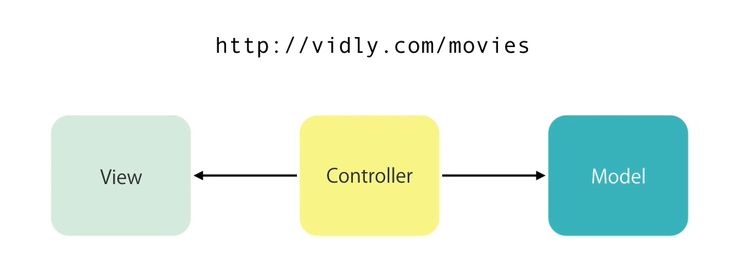

Imagine this scenario. User want to go to this address. Controller will get all the movies from database, put them in the view and return the view to the client/browser.

Router

* Selects the right controller to handle a request.

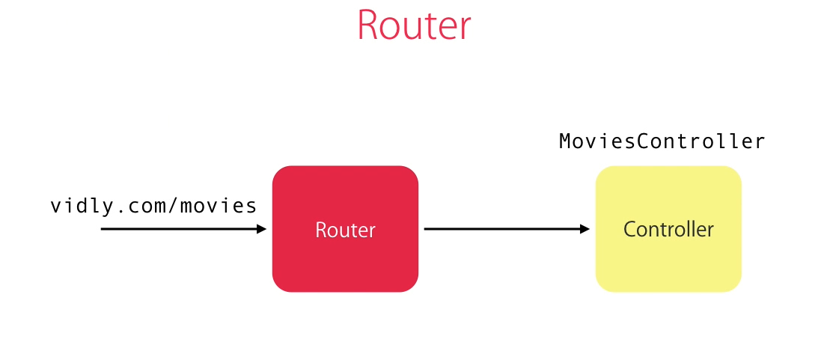

In this case, router will handle that the incoming request will be handled by a class called MoviesController.